HISTORY OF ART DEPARTMENT
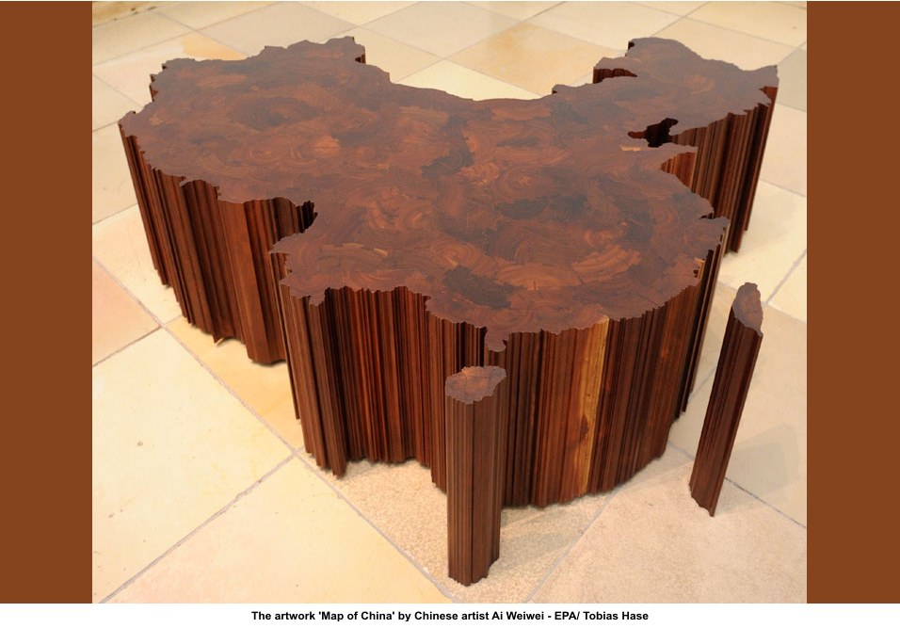
AI WEIWEI AND CONTEMPORARY ART FROM CHINA

On the occasion of Ai Weiwei’s exhibition in the Tate Modern turbine hall, the first such commission for an artist from the Asia-Pacific region, the History of Art Department is hosting a major event to debate the significance of contemporary Chinese art and its reception in the UK. Speakers include the exhibition’s curator and leading scholars in the field.

Marko Daniel (Tate Modern), ‘The Reception of Chinese Art in the UK’
Wenny Teo (UCL), 'Critical Masses: The Ornamental and the Monumental in the work of Ai Weiwei'
Juliet Bingham (Tate Modern), ‘The Unilever Series: Ai Weiwei’

Wednesday 10 November 2010, 14:15-17:15, Lecture Theatre, Berrick Saul Building
ALL WELCOME

